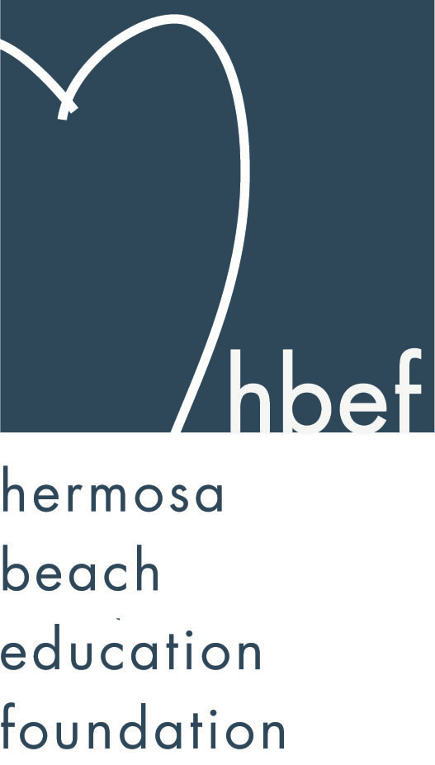Hermosa Beach Education Foundation
Board Meeting Minutes
Tuesday, March 12, 2013

Attendees:
Amy Nachman Brian Ledermann Cathy Barrow Courtney Unser
Doug Gneiser Gia Busse Greg Roth Heather Meugniot
Jenn Auville Jennifer Forier Karen Buchhagen Kim Bailey
Kimberly Konis Kimberly Taylor Laurie Baker Lili McLean
Maggie Curtis Mary Delk Michelle WeissenbergNicole Perez
Pat Escalante Patrick Goshtigian Patti Ackerman Sam Rudow
Shelby Gonosey Stephanie Bell Sue Antrobius Sylvia Gluck

Board Members Not Present:
Barbara Gunning Dan Inskeep Dawn Crawford Dina Stern
Donna Gin Gloria Vialpando Jenny Durand Michelle Lohuis
Monique Vranesh Naomi Immel Suzy Stouder

Call to Order
Meeting called to order by Stephanie Bell at 7:38pm

Flag Salute

Approval of Minutes
Maggie Curtis made a motion to approve the January 15, 2013 minutes. Michelle Weissenberg seconded the motion. Motion carried by voice vote.

Executive Board Reports
Stephanie Bell, President
Skechers donated $35,000 to HBEF from the Pier to Pier Walk on October 28, 2012. HBEF will be voting at the next meeting to fund a Friendship Circle program at both View and Valley using some of the money donated from Skechers.

HOH auction books have been printed and are available in the View and Valley offices. There will also be tables at both campuses before and after school to promote the event. In an attempt to be more green, this is the last year HOH will have an auction booklet.

Kinder roundup will be held on April 17, 2013 at Hermosa View. HBEF will have representatives to explain the events the HBEF holds, what the HBEF funds, and HBEF volunteer opportunities.
Brian Ledermann/Amy Nachman, CO-VP Operations - Policy and Procedures
Brian and Amy will be forming a committee to review and revise the HBEF bylaws.

Jenn Auville, CO-VP Operations – Communication
Jenn distributed the commitment to return forms to the HBEF board members to be signed and returned. Nominations for new members were also accepted.

Jennifer Forier, Secretary
Jennifer had nothing to report.

Michelle Weissenberg, VP CFO Treasurer
It is mid quarter so there are no new financial reports. Most of the teacher grants have been paid out.

Patrick Goshtigian, VP CIO Investments
Patrick reviewed the Portfolio Asset Allocations as of February 28, 2013. Current market value is $1,084,016. The portfolio showed a 3.3% total return. Benchmark was 3.9%. Overall, the portfolio is up $34,557 for the year.

Maggie Curtis and Shelby Gonosey, CO-VP Annual Appeal
Annual Appeal, as of the end of February, has raised $228,000. The Annual Appeal promotions and communications will be quiet until after HOH. After HOH, new banners will be going up at both campuses, a class competition will take place at View, and teachers will be offered $100 Hang 10 cards.

Kimberly Konis, CO-VP Fundraising
Hearts of Hermosa planning is going strong. Karen Buchhagen gave a lesson on how to use smartphones to mobile bid on auction items at HOH. The auction will close at 9:00pm. All items should be picked up at HOH. Reconciliation will take place Sunday from 10:00am to 1:00 pm and Monday 10:00am to 1:00pm in the Hermosa Beach Museum.

South Bay Ford and Lincoln will be running a promotion in April to benefit the HBEF. A flier will go out in the Surf Report. For each person that presents the promotion flier, $20 will be donated to the HBEF for a test drive and $200 will go to the HBEF if a car is purchased.

Dawn Crawford, VP Sponsorships
Dawn was unable to attend the meeting but sent an update via email. Sponsorship has reached $150,150 of which $115,000 is in hand.

Laurie Baker, VP PR/Communications
Laurie has been promoting HOH. There is a banner on Pier Avenue, posters up around campuses and town, information on the school and city marquees, an article in the beach reporter, Facebook posts and blurbs in the Surf Report.

Activities Completed for 2012-2013
Wine Walk – raised about $20,000.
Fall Mixer – Thank you to the Goshtigian family for hosting the event.
HBFA Poker and Casino Night - $1000 donated to the Annual Appeal
McTeacher’s Night - $2,000 donated to the HBEF
Skecher’s Friendship Circle Pier to Pier Walk – no numbers yet
Gum Tree Santa – raised about $4,000
Mom’s Night Out at The Comedy and Magic Club – raised about $8,700

Other Reports
PTO, Greg Roth
Father Daughter Dance will be held April 12, 2013. HVPTO is looking into doing a summer camp roundup with food trucks.

Superintendent, Pat Escalante
There has been a lot of positive media coverage for the schools and school events lately. A safety audit is ongoing at both campuses and a follow up presentation will take place when all the results have been discovered. Layoff notices have been given to staff and the HBCSD hopes that the HBEF fundraising efforts will help be able to rescind all notices before summer as it did last year.

School Board Representative, Patti Ackerman
The joint School Board and City Council meeting held in January went well. A state of the district was presented, the city showed its willingness to support the school board and school safety was discussed. There will be another joint meeting before yearend. The facilities committee is looking at options for the North campus. A land swap, rebuilding on the site and retrofitting are all being looked at. The next school board meeting will be held Wednesday, March 13, 2013.

View and Valley Principals, Sylvia Gluck (View) and Kim Taylor (Valley)
View will hold Kinder Roundup on April 17, 2013 at 5:00pm. Three kindergarten tours will be available, one in April, one in May and one in June. There will be a flag ceremony on April 19, 2013. Earth Day will be celebrated on April 22, 2013.

Valley will have a flag ceremony on April 26, 2013. There will be a Title I informational parent meeting on March 19, 2013 at 5:30pm in the Valley MPR. Star Testing will occur May 6-10, 2013. Friendship Circle programs will be forming at both campuses. The middle school science team placed 4th in the Science Olympiad and they will be going to the state competition. Sixth graders are at camp in Malibu this week. Read Across America was a success.

Valley Teacher Representatives, Cathy Barrow (6-8) and Mary Delk (3-5)
The fifth graders enjoyed Read Across America and Colonial Day. Walk Through the Revolution is coming up in April.

Eighth graders had a great time at Astronomy Camp. High School registration for the eighth graders went well. Plans for eighth grade graduation are underway. The 8th/3rd grade writing project will start in April.

View Teacher Representative, Gia Busse (K-2)
The teachers at View are using their iPads and finding them to be very useful in their classroom instruction. The kindergarten teachers attended a seminar on Daily 5 and are implementing the program in their classes. The kindergartens had a great field trip to the Experium Science Academy in Torrance.

Roundtable/Questions/Guests
HB5000 participation was very low in 2012. HBEF has decided not to participate in the event in 2013. The event is planned for April 21, 2013.

Fiesta Hermosa will have a section for nonprofit organizations. HBEF has decided not to participate in the Memorial Day Fiesta Hermosa but will explore options for a booth at the Labor Day Fiesta.

HOH set up will take place Friday, March 22,2013 from 6:00-10:00pm and Saturday all day. All are welcome to come help.

Calendar
Upcoming 2012-13 HBEF Events
March 23, 2013 – Hearts of Hermosa

Upcoming 2012-13 HBEF Meetings
April 30, 2013 – 7:30pm in Tech Lab
June 11, 2013 – 7:30pm in Tech Lab
July 9, 2013 – 7:30pm in Tech Lab

Adjournment
Stephanie Bell adjourned the meeting at 8:50pm.

Respectfully submitted by Jennifer Forier

