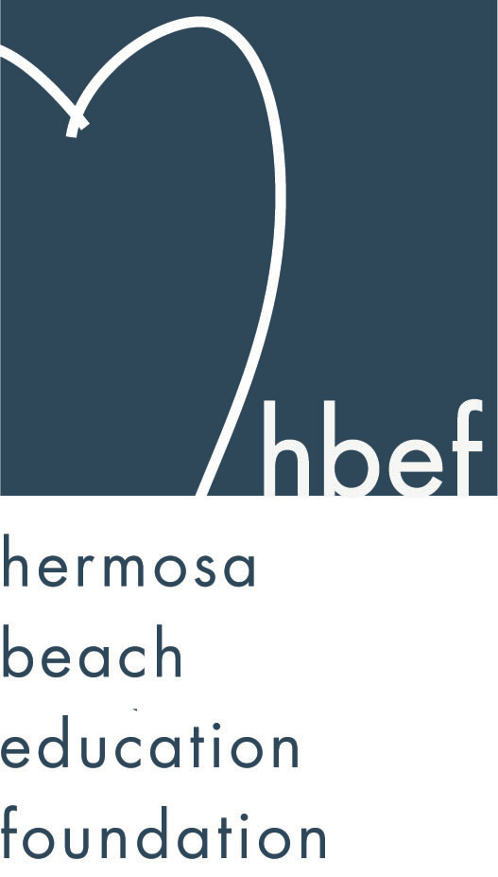Hermosa Beach Education Foundation
Board Meeting Minutes
Tuesday, April 30, 2013

Attendees:
Amy Nachman Cathy Barrow Chad Falhbush Courtney Unser
Cyndi Wills Dan Inskeep Dawn Crawford Dina Stern
Donna Gin Gia Busse Heather Meugniot Jenn Auville
Jennifer Forier Jenny Durand Kim Bailey Kimberly Konis
Kimberly Taylor Laurie Baker Lili McLean Maggie Curtis
Michelle Weissenberg Nicole Perez Pat Escalante Patti Ackerman
Sam Rudow Stephanie Bell Suzy Stouder Sylvia Gluck

Board Members Not Present:
Barbara Gunning Brian Ledermann Doug Gneiser Gloria Vialpando
Greg Roth Karen Buchhagen Mary Delk Michelle Lohuis
Monique Vranesh Naomi Immel Patrick Goshtigian Shelby Gonosey
Sue Antrobius

Call to Order
Meeting called to order by Stephanie Bell at 7:35pm

Flag Salute

Approval of Minutes
Stephanie amended the amount of money raised at Mom’s Night Out at The Comedy from $8,700 to $9,100. Maggie Curtis made a motion to approve the March 12, 2013 minutes. Kimberly Konis seconded the motion. Motion carried by voice vote.

Executive Board Reports
Stephanie Bell, President
An anonymous donor has donated three checks, totaling $100,000, to the HBEF. A discussion on how to divide this donation between Annual Appeal and the endowment was held. No decision was made at this time.

Sebastian Kuhr held his 7th annual Skate For the Schools on April 26, 2013. His event raised over $4,000 for the HBEF.

Poker Night on May 18, 2013 at 5:00pm still has about 30 spots. $100 gets you in the door for food, cocktails and raffle items. There is an additional $150 buy in to play.
The HBEF entered the drawing for nonprofits to be a part of the Memorial Day Weekend Fiesta Hermosa Beer Garden. HBEF did not win a spot. HBEF will enter the drawing for a spot in the Labor Day Weekend Fiesta Hermosa. A new nonprofit area is being created at the Fiesta and HBEF is looking into having something in that area for the Labor Day weekend Fiesta.

Kinder roundup was held on April 17, 2013 at Hermosa View. HBEF representatives, Stephanie Bell and Maggie Curtis, were there to explain the HBEF’s annual events, what the HBEF funds, HBEF volunteer opportunities, and the Annual Appeal.

2013-2014 HBEF Meeting Dates have been set for; September 24, 2013, November 12, 2013, January 14, 2014, March 11, 2014, May 13, 2014, June 10, 2014, and July 8, 2014.

2013-2014 HBEF Event Dates have been set for; Back to School Picnic on September 13, 2013, Skechers Pier to Pier Walk on October 27, 2013 and Hearts of Hermosa on March 22, 2014.

Brian Ledermann/Amy Nachman, CO-VP Operations - Policy and Procedures
Brian was not in attendance.
Amy reported that the Hearts of Hermosa raised about $250,000 plus an additional $20,000 for the Annual Appeal. Another $10,000 in sponsorship is still expected.

Jenn Auville, CO-VP Operations – Communication
Jenn reported that the HBEF bylaws are being reviewed and revised. Jenn is working on finalizing the 2013-14 HBEF Board to be voted in at the June 11, 2013 HBEF meeting.

Jennifer Forier, Secretary
Jennifer is working on updating the job descriptions for HBEF Board Members. Any input is welcome.

Michelle Weissenberg, VP CFO Treasurer
Michelle presented a financial report as of March 31, 2013.

Patrick Goshtigian, VP CIO Investments
Patrick was not in attendance. Michelle reviewed the Portfolio Asset Allocations as of April 17, 2013. Current market value is $1,098,509. The portfolio showed a 4.7% total return. Benchmark was 6.0%. Overall, the portfolio is up $49,049 for the year.

Maggie Curtis and Shelby Gonosey, CO-VP Annual Appeal
Annual Appeal, as of the end of April, has raised $352,000 with thirty-three percent participation from HBCSD families and seventy percent participation from the HBEF Board. 100% participation is the ultimate goal. There is a class competition being held at View and ends May 17, 2013. There will be a change jar competition at Valley.

Kimberly Konis, CO-VP Fundraising
Kimberly had nothing to report.
Dawn Crawford, VP Sponsorships
Sponsorship has reached $155,625 for the year. Dawn is in the process of distributing new window decals to the HBEF sponsors.

Laurie Baker, VP PR/Communications
Laurie has been promoting the Annual Appeal. HBEF has 327 Facebook friends.

Activities Completed for 2012-2013
Wine Walk – raised about $20,000.
Fall Mixer – Thank you to the Goshtigian family for hosting the event.
HBFA Poker and Casino Night - $1000 donated to the Annual Appeal
McTeacher’s Night - $2,000 donated to the HBEF
Skecher’s Friendship Circle Pier to Pier Walk – no numbers yet
Gum Tree Santa – raised about $4,000
Mom’s Night Out at The Comedy and Magic Club – raised about $9,100
Hearts of Hermosa – raised about $250,000
Skate For The Schools – raised about $4,000

Other Reports
PTO, Greg Roth
Greg was not in attendance.

Superintendent, Pat Escalante
Pat encouraged attendance at the May 8, 2013 School Board Meeting where the HBCSD staff will be receiving their years of service pins.

School Board Representative, Patti Ackerman
The 2013-14 school year calendar has been approved. There will be another joint School Board and City Council meeting May 29, 2013 at 7pm in the Hermosa Beach City Council Chambers. The facilities committee reached the end of it’s first assigned task and presented it’s findings to the School Board. The committee will continue to meet to look at more options among the school districts various properties. The next school board meeting will be held Wednesday, May 8, 2013.

View and Valley Principals, Sylvia Gluck (View) and Kim Taylor (Valley)
Sylvia Gluck reported for View. State Testing will be held May 6-10, 2013. First Grade is currently doing post office. Dolphin time is going well. View is seeing a lot of reading growth in all grade levels. Kinder roundup went well. New student registration is online this year. View Open House is Thursday, May 23, 2013.

Kimberly Taylor reported for Valley. State Testing will be held May 6-10, 2013. There will be a third grade transition meeting for parents of second graders on June 3, 2013 at 6pm in the Valley MPR. There will be a middle school transition meeting for parents of fifth graders on June 4, 2013 at 6pm in the Valley MPR. Middle School registration is tentatively set for August 27, 2013. Valley Open House is Thursday, May 30, 2013.

Valley Teacher Representatives, Cathy Barrow (6-8) and Mary Delk (3-5)
Writer’s Workshop has been very beneficial this year and the staff feels like it has helped them form a clear articulation of skills through the grade levels. Eighth grade graduation plans are underway. The eighth graders have finished their books and will be presenting them to third graders in June. Science Olympiad team placed 19th in State. Eighth graders’ NASA video came in 2nd in the nation.

Mary Delk was not in attendance.

View Teacher Representative, Gia Busse (K-2)
Kinder roundup went well. There are 115 incoming kindergarteners scheduled for screening on June 5th and 12th. Screenings will help the administrators to create balanced kindergarten classes.

Roundtable/Questions/Guests

Calendar
Upcoming 2012-13 HBEF Events

Upcoming 2013-14 HBEF Events
September 13, 2013 – Back To School Picnic
October 27, 2013 – Skechers Pier To Pier Walk
March 22, 2014 – Heart of Hermosa

Upcoming 2012-13 HBEF Meetings
June 11, 2013 – 7:30pm in Valley Tech Lab
July 9, 2013 – 7:30pm in Valley Tech Lab

Upcoming 2012-13 HBEF Meetings
September 24, 2013 – 7:30pm in Valley Tech Lab
November 12, 2013 – 7:30pm in Valley Tech Lab
January 14, 2014 – 7:30pm in Valley Tech Lab
March 11, 2014 – 7:30pm in Valley Tech Lab
May 13, 2014 – 7:30pm in Valley Tech Lab
June 10, 2014 – 7:30pm in Valley Tech Lab
July 8, 2014 – 7:30pm in Valley Tech Lab

Adjournment
Stephanie Bell adjourned the meeting at 8:38pm.

Respectfully submitted by Jennifer Forier

