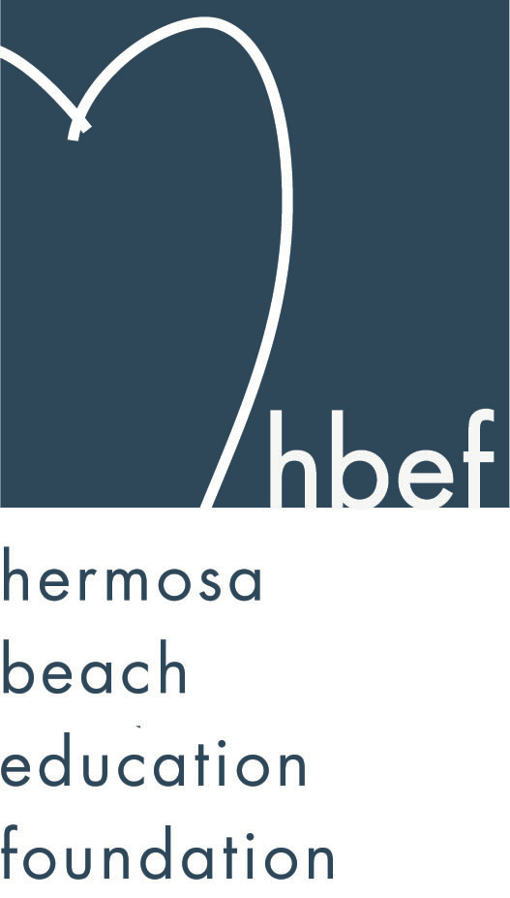Hermosa Beach Education Foundation
Board Meeting Minutes
Tuesday, June 11, 2013

Attendees:
Allison Ludlow Amy Nachman Schmargen Barbara Gunning
Brian Ledermann Brian Parker Cathy Barrow Cindy Butler
Courtney Unser Cristina Kabealo Cyndi Wills Dan Inskeep
Dawn Crawford Dina Stern Donna Gin Doug Gneiser
Gia Busse Gloria Vialpando Greg Roth Heather Baboolal Heather Meugniot Heather Olson Jessica Walls Jenn Auville
Jennifer Forier Jenny Durand Jenny Fix Kimberly Konis
Laurie Baker Lili McLean Lynn Barr Maggie Curtis Michelle Lohuis Michelle Weissenberg Nicole Perez Pat Escalante
Stephanie Bell Suzy Stouder Zipporah Kiger

Board Members Not Present:
Karen Buchhagen Kim Bailey Kimberly Taylor Mary Delk
Monique Vranesh Naomi Immel Patrick Goshtigian Patti Ackerman
Sam Rudow Shelby Gonosey Sue Antrobius Sylvia Gluck

Call to Order
Meeting called to order by Stephanie Bell at 7:34pm

Flag Salute

Approval of Minutes
Heather Meugniot made a motion to approve the April 30, 2013 minutes. Jenn Auville seconded the motion. Motion carried by voice vote.

Executive Board Reports
Stephanie Bell, President
Stephanie welcomed the new members to the 2013-14 HBEF Board and introductions were made. Stephanie also thanked the outgoing board members for their past hard work and dedication to the HBEF.

Sebastian Kuhr held his 7th annual Skate For the Schools on April 26, 2013. His event raised $4,282 for the HBEF.

The Bank of Manhattan Poker Tournament on May 18, 2013 at 5:00pm was a success and raised $7,500 for the HBEF’s Annual Appeal. This may become an annual event.

An anonymous donor has donated three checks, totaling $100,000, to the HBEF. A discussion on how to divide this donation between Annual Appeal and the endowment was held. Several Board members feel that the entire sum should go to the endowment so the money will have a long lasting legacy in the district. No decision was made at this time.

Brian Ledermann/Amy Nachman, CO-VP Operations - Policy and Procedures
Brian and Amy are working on updating the bylaws and hope to have a draft available for approval at the July HBEF meeting.

Jenn Auville, CO-VP Operations – Communication
Jenn had nothing to report. This was Jenn’s last HBEF meeting as CO-VP Operations-Communications. The Board is very thankful for Jenn’s years of service. The role of CO-VP Operations – Communication has been restructured and renamed, Vice-President, for 2012-13. The position is currently vacant.

Jennifer Forier, Secretary
Jennifer distributed and discussed the Commitments and Expectations of an HBEF Board member, which were revised on June 11, 2013. Part of the expectation for all Board members is that they sign up for a HBEF Board position. A sign up sheet, with available positions, was explained and distributed. It is also an expectation that all Board members will volunteer and assist with the Hearts of Hermosa fundraiser so a HOH volunteer sign up sheet was also explained and distributed. The Commitments and Expectations form needs to be signed by all Board members, their Board position and HOH position filled in, and returned to Jennifer Forier by the July HBEF meeting. Jennifer also passed around the snack sign up sheet for the 2013-14 HBEF meetings. Jennifer will be working to update the HBEF roster to reflect the changes in members for 2013-14.

Michelle Weissenberg, VP CFO Treasurer
Michelle reviewed how the money earned during the annual fundraising of the HBEF is allocated. $15,000 is set aside each year for teacher grants. For all traditional fundraising efforts that occur each school year, 80% of the profits are ultimately donated to the school district along with the Annual Appeal monies. The other 20% of profits are placed in an endowment fund. Each year a small operating budget is carried over as well.

Final numbers are not in, but after the 2012-13 fundraising efforts of the HBEF approximately $220,000 will be available to donate to the HBCSD. This number does not include Annual Appeal money. In addition, approximately $60, 000 will be placed in the endowment.

Michelle reminded the Board that all reimbursement requests for the 2012-13 school year need to be submitted no later than June 19, 2013. A proper reimbursement form needs to be submitted with all requests. Two board members and the treasurer need to approve the request. Please follow the proper procedure when submitting forms.

This was Michelle’s last meeting as VP CFO Treasurer. The Board is very thankful for Michelle’s years of service . Dan Inskeep will be taking over the position for 2013-14.

Patrick Goshtigian, VP CIO Investments
Patrick was not in attendance. Brian reviewed the Portfolio Asset Allocations as of May 31, 2013. Current market value is $1,126,233. The portfolio showed a 7.3% total return. Benchmark was 8.9%. Overall, the portfolio is up $76,773 for the year.

Brian reminded the board that the goal of the endowment fund is $2,000,000. When the fund reaches this amount 5% of the endowment will begin to be given back to the HBEF annually, about $100,000 a year. There is an investment committee that analyzes how the money should be invested.

Maggie Curtis and Shelby Gonosey, CO-VP Annual Appeal
Annual Appeal, as of June 11. 2013, has raised $562,891 with 57 percent participation from HBCSD families and one hundred percent participation from the HBEF Board. The HBEF raised an additional $220,000 to donate to the HBSCD. The PTO has raised an additional $37,000 to donate to the HBCSD. Thus, the total available to grant to the HBCSD for 2013-14 is $819,891. This number may change since there are still 4 more days for the Annual Appeal which ends Saturday, June 15, 2013. Emails and an all call are scheduled for the last few days of the Appeal.

Kimberly Konis, CO-VP Fundraising
Kimberly’s fundraising efforts for the year are complete.

Dawn Crawford, VP Sponsorships
Sponsorship has reached $155,940 for the year. 12%, or $19,065 came from Hang 10 partners. 18%, or $27,300 came from Real Estate Partners. 30%, or $47,250, came form Family Sponsors. 40%, or $62,425, came from Community Partners.
This was Dawn’s last meeting as VP Sponsorships. The Board is very thankful for Dawn’s years of service. Heather Olson will be taking over the position for 2013-14.

Laurie Baker, VP PR/Communications
Laurie has been promoting the Annual Appeal. Laurie is working to set up a constant contact system for the HBEF so that communications no longer needa to go through the HVPTO’s system. The HVPTO has been very generously sharing their system but as the needs for electronic communications continue to grow for both organizations the HBEF would like to be able to send their own communications and not have to continue to overload the PTO volunteers with their requests. South Bay Magazine is doing a locals choice competition for best charity event of the year. Hearts of Hermosa has been nominated. Board members are encouraged to vote. The HBEF has 334 Facebook friends.

Activities Completed for 2012-2013
Wine Walk – raised about $20,000.
Fall Mixer – Thank you to the Goshtigian family for hosting the event.
HBFA Poker and Casino Night - $1000 donated to the Annual Appeal
McTeacher’s Night - $2,000 donated to the HBEF
Skecher’s Friendship Circle Pier to Pier Walk – $35,000
Gum Tree Santa – raised about $4,000
Mom’s Night Out at The Comedy and Magic Club – raised about $9,100
Hearts of Hermosa – raised about $250,000
Skate For The Schools – raised $4,282
Bank of Manhattan Poker Tournament – raised $7,500

Other Reports
PTO, Greg Roth
Valley Field Day is scheduled for Thursday, June 20, 2013. Fifth grade Beach Day is Thursday, June 20, 2013. Fourth grade boat races are Thursday, June 20, 2013. View Field Day is Friday, June 21, 2013.

Superintendent, Pat Escalante
Pat thanked the HBEF Board Members and volunteers for their hard work and dedication. Thanks to the support of the HBEF, the community and the parents that support fundraising efforts and donate to the Annual Appeal the HBCSD will be able to rescind all lay off notices at the June 12, 2013 School Board Meeting and save value school programs, despite the $2,000,000 annual shortfall. Hermosa is a 10/10 school with the highest API score in the South Bay. Eighth grade graduation is scheduled for Friday, June 21, 2013 at 6:30pm at Mira Costa High School. There will be 4 modular classrooms placed on the View campus and 2 on the Valley campus to help accommodate the large number of students at both campuses.

School Board Representative, Patti Ackerman
Patti was not present. The next School Board Meeting will be held on Wednesday, June 12, 2013.

View and Valley Principals, Sylvia Gluck (View) and Kim Taylor (Valley)
Sylvia Gluck was not present.
Kimberly Taylor was not present.

Valley Teacher Representatives, Cathy Barrow (6-8) and Mary Delk (3-5)
The eighth graders have finished their books and will be presenting them to third graders on Wednesday, June 12, 2013.

Mary Delk was not in attendance.

View Teacher Representative, Gia Busse (K-2)
Incoming kindergarteners are being screening on June 5th and 12th. Screenings will help the administrators to create balanced kindergarten classes. Kindergarteners have been taking their field trips to Vons and the police station. First grade is finishing up their post office, letter-writing unit.

Roundtable/Questions/Guests

Calendar
Upcoming 2013-14 HBEF Events
September 13, 2013 – Back To School Picnic
October 27, 2013 – Skechers Pier To Pier Walk
March 22, 2014 – Hearts of Hermosa

Upcoming 2013-14 HBEF Meetings
July 9, 2013 – 7:30pm in Valley Tech Lab
September 24, 2013 – 7:30pm in Valley Tech Lab
November 12, 2013 – 7:30pm in Valley Tech Lab
January 14, 2014 – 7:30pm in Valley Tech Lab
March 11, 2014 – 7:30pm in Valley Tech Lab
May 13, 2014 – 7:30pm in Valley Tech Lab
June 10, 2014 – 7:30pm in Valley Tech Lab
July 8, 2014 – 7:30pm in Valley Tech Lab

Adjournment
Stephanie Bell adjourned the meeting at 8:55pm.

Respectfully submitted by Jennifer Forier

