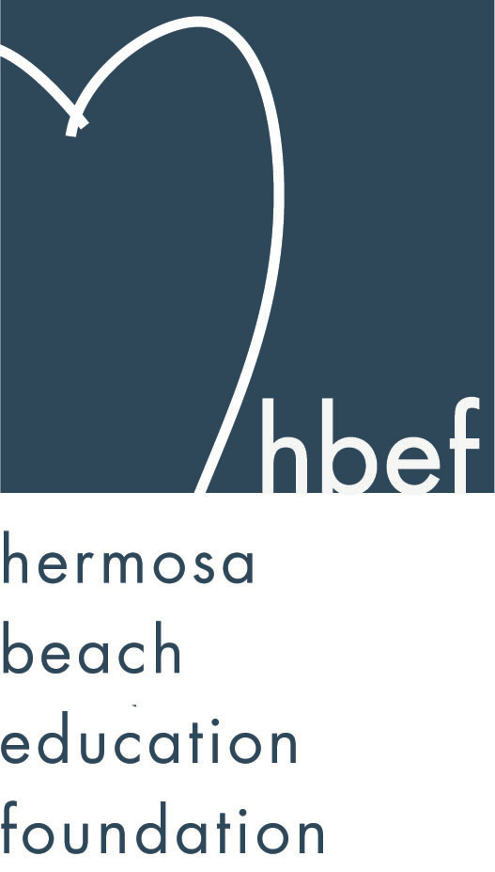Hermosa Beach Education Foundation
Board Meeting Minutes
Tuesday, June 10, 2014

Attendees:
Ali Malone Allison Ludlow Brian Ledermann Brian Parker
Carla Persell Carol Herschelman Cathy Barrow Cindy Butler Courtney Unser Cristina Kabealo Dan Inskeep Debra Luckey
Dina Stern Donna Gin Doug Gneiser Gail Laskowski
Gia Busse Greg Roth Heather Meugniot Heather Olson Jennifer Forier Jenny Fix Jessica Walls Kim Bailey
Kimberly Konis Kimberly Taylor Laurie Baker Lisa Claypoole
Lisa Searer Louisa Cushman Lynn Barr Maggie Curtis
Michelle Weissenberg Monique Vranesh Nicole Perez Pat Escalante
Shelby Gonosey Stephanie Bell Suzy Stouder Sylvia Gluck
Tiffany Miller Tiffani Soporito Zipporah Kiger Veronica Ruston
Bobbi Newman Chris Hodge Mevan Randeniya

Board Members Not Present:
Amy Nachman Schmargen David Hart Karen Buchhagen Patrick Goshtigian

Call to Order
Meeting called to order, in the Valley Multipurpose Room, by Stephanie Bell at 7:37pm.

Flag Salute

Approval of Minutes
Dan Inskeep made a motion to approve the May 13, 2014 minutes. Kimberly Konis seconded the motion. Motion carried by voice vote.

Executive Board Reports

Stephanie Bell, President
Stephanie thanked the 2013-14 event chairs for their fundraising efforts:
Back to School Picnic – Cristina Kabealo - $720.
Santa Photos at gum tree – Lynn Barr - $5,839
Wine Walk – Courtney Unser, Allison Ludlow, Doug Gneiser, Donna Gin, Zipporah Kiger - $31,543
Skecher’s Walk – Donna Gin, Monique Vranesh - $60,048.58
Mom’s Night Out – Jenny Fix - $11,535
Hearts of Hermosa – Heather Meugniot and all board members - $120,571.83
Sponsorship – Heather Olson - $128,705
Hang 10 – Debra Luckey - $4,200
Non-Board Activities –
Love Letters - $7,232
McTeacher Night - $1,274.66
Commissions for Education - $1,944
Thanks to everyone’s efforts HBEF had a record high for 2013-14 fundraising efforts.

Stephanie Bell will be stepping down after four years as president. Ali Malone will be taking over.

Brian Ledermann/Amy Nachman, Operations - Policy and Procedures
Amy was not in attendance. Amy will be stepping down. Brian will have a whole vote going forward.
Brian asked that all event paperwork be submitted to close out 2013-14 and for placement in storage. Any relevant documents should also be placed in the Dropbox for access from the board as needed.

Jennifer Forier, Secretary
The 2014-15 HBEF roster was passed for updates and corrections. A list of dates for 2014-15 HBEF meetings and events was provided. (See below for all dates.) A snack and water sign up for the 2014-15 meetings was passed. The Commitments and Expectations for 2014-15 were discussed and the form was passed out for signatures.

Dan Inskeep, Treasurer
Dan reviewed the profit and loss sheet and balance sheet for July1, 2013 through June 2, 2014. The general fund balance available for distribution to the HBCSD, minus $15,000 teacher grants, $1,500 3rd/8th grade books and $5,000 operating cash, is $388,581.98. 80% of this, $310,865.58 will go to the district, pending board vote and $77,716.40, or 20%, will be going to the HBEF endowment.

Patrick Goshtigian, CIO Investments
Patrick was not in attendance. Brian presented the Portfolio Asset Allocation as of May 31, 2014 for review. The portfolio showed a 4.0% total return. This is slightly lower than the benchmark (4.5%). Ending market value is $1,438,823. Overall, the endowment was up $54,882 for 2014. Stephanie reviewed a summary of the endowment over the past 5 years. On 5/31/09 the endowment was at $514,529.92 and on 5/31/14 it was at $1,438,822.66. During the 5 years, there were $476,562.07 of net contributions and $447,730.67 of investment gains.

Maggie Curtis and Shelby Gonosey, Annual Appeal
Annual appeal closed on June 6, 2014 with 100% board participation, 59% family participation and $625,000 raised. This is a record high for annual appeal. Shelby and Maggie are stepping down. Lisa Searer and Gail Laskowski are taking over. Nicole Perez and Allison Ludlow will be assisting.

Kimberly Konis, Fundraising
Fundraising events for the year are over. All events were a success. Kimberly is stepping down. Lynn Barr will be taking her place.

Heather Olson, Sponsorships
Heather reported that sponsorship closed at a record high for the year.

Laurie Baker, Public Relations
Laurie will be sending out the annual HBEF newsletter in August. Laurie is promoting the HBEF through Facebook, Twitter and Constant Contact emails. HBEF has 512 Facebook friends. Hang 10 promotions are going out monthly.

Board Action
The board voted on three items: 1) authorizing the Treasurer to transfer all available funds to the district for use as presented by Superintendent Pat Escalante. This grant is in the amount of $310,865. 2) re-electing Board directors and electing new board directors for a 2 year term and 2) electing Executive Board directors for a 1 year term.

A review of how HBEF funds are allocated was reviewed. At year-end, from the total cash available, $21,500 is set-aside for the following year ($15,000 teacher grant, $1,500 Barrow books, $5,000 operating cash.) The remaining is split 80/20. Eighty percent goes to the district. Twenty percent goes in to the HBEF endowment. The goal for the endowment is $2,000,000.
Stephanie reviewed the grants for the last 4 years: 2011 - $170,413, 2012 - $176,610, 2013- $223,233 and 2014 - $310,865.

District Grant
Pat Escalante Pat requested $110,000 for Elementary School Science (grades 3-5), $73,843 for School Libraries, $47,918 for 1-5 PE Program and $79,104 for Middle School Electives. This represents a grant of $310,865. Doug Gneiser made a motion to authorize the Treasurer to transfer $310,865 to the HBSCD for use as presented by Superintendent Pat Escalante. Debra Luckey seconded the motion. Motion carried by voice vote.

The election slate of new board directors and board directors re-elect for the 2014-2015 school year was reviewed.
Board Directors Re-elect – Two Year Term – 2014/2015-2015/2016:
Courtney Unser, Dan Inskeep, Donna Gin, Doug Gneiser, Heather Meugniot, Kimberly Konis, Laurie Baker, Maggie Curtis, Monique Vranesh, Nicole Perez and Suzy Stouder.
New Directors Elect – Two-Year Term – 2014/2015-2015/2016:
Ali Malone, Carla Persell, Gail Laskowski, Lisa Searer, Tiffani Miller, Tiffany Soporito
Continuing Board Directors – term ending 2015 (info only, no vote needed):
Allison Ludlow, Brian Ledermann, Brian Parker, Carol Herschelman, Cindy Butler, Cristina Kabealo, Debra Luckey, Heather Olson, Jennifer Forier, Jenny Fix, Jessica Walls, Karen Buchhagen, Lynn Barr, Michelle Weissenberg, Patrick Goshtigian, Zipporah Kiger.
Board Directors - stepping down June 2014 (info only, no vote required):
Amy Schmargen Nachman, Dina Stern, Kim Bailey, Shelby Gonosey, Stephanie Bell

Re-elect Board Directors and Elect New Board Directors for 2014/2015-2015/2016
Maggie Curtis made a motion to re-elect Board Members and elect new Board Members slated for a 2-year term. Heather Meugniot seconded the motion. Motion carried by voice vote.

The election slate of executive board directors for 2014-2015 was reviewed.
Executive Board – One Year term (selected from board) – 2014/15:
Ali Malone – President, Brian Lederman – Operations – Policy and Procedure, Dan Inskeep – CFO Treasurer, Gail Laskowski – Annual Appeal, Heather Olson – Sponsorships, Jennifer Forier – Secretary, Laurie Baker – Public Relations, Lisa Searer – Annual Appeal, Lynn Barr – Fundraising, Patrick Goshtigian – CIO Investments.

Elect Executive Board Officers for 2014/2015
Jenny Fix made a motion to elect the slated Executive Board directors for a 1-year term. Doug Gneiser seconded the motion. Motion carried by voice vote.

Activities Completed for 2013-2014
September 13, 2013 – Back To School Picnic
October 8, 2013 - HBEF Fall Mixer
October 19, 2013 – Wine Walk
October 27, 2013 – Skecher’s Pier To Pier Walk
December 1, 2013 - Santa Photos at gum tree 10-4pm
December 8, 2013 - Santa Photos at gum tree 10-4pm
January 29, 2014 - Mom’s Nights Out at The Comedy and Magic Club
March 22, 2104 – Hearts of Hermosa
Annual Appeal – closed June 6, 2014

Other Reports

PTO, Greg Roth
Jenny Fix and Louisa Cushman were elected as the new HVPTO’s Co-Presidents. The PTO voted to approve $170,000 in allocations for the 2014-15 school year.

Superintendent, Pat Escalante
Pat thanked the HBEF for its fundraising efforts and continued support of the HBCSD.

School Board Representative, Lisa Claypoole
Lisa thanked the HBEF for their 2013-14 fundraising efforts. The next school board meeting is Wednesday, June 11, 2014.

View and Valley Principals, Sylvia Gluck (View) and Kim Taylor (Valley)
Sylvia reported that there will be a flag ceremony on Friday, June 13, 2014 for perfect attendance and accelerated reader awards. Field Day will be June 18, 2014. Sylvia thanked the HBEF and all the parent volunteers that made the 2013-14 school year such a success.

Kim reported that seventh grade had a Mind Up day on Monday, June 9, 2014. The 2nd/3rd grade parent transition meeting was held Monday, June 9, 2014. The 5th/6th grade transition meeting will be held Monday, June 16, 2014. The 2014-15 middle school elective packages are being emailed out to parents for selection. Valley will have a flag ceremony June 13, 2014. Sixth graders are participating in a dance residency. June 17, 2014 there will be a perfect attendance assembly. June 18, 2014 is the staff versus eighth grade softball game. June 19, 2014 is the fifth grade beach day, 3rd/4th grade field day and eighth grade goes to Disneyland. Eighth graduation and dance is June 20, 2014.

View Teacher Representative, Gia Busse (K-2)
Kindergarten students just wrapped up the community unit and visited Vons.

Valley Teacher Representatives, Cathy Barrow (6-8) and David Hart (3-5)
David was not in attendance.

Cathy reported that the eight graders presented their books to the third graders on Friday, June 6, 2014. Cathy thanked the HBEF for funding this project. Eighth graders are excited to graduate.

Roundtable/Questions/Guests
Chris Hodge from Opportunities for Youth and Opportunities for Education spoke about their charter program. The charter program has a contract with the HBCSD that is up for renewal. Chris invited the HBEF to attend the School Board Meeting on June 11, 2014 to learn more about the program.
Bobbi Newman was also present to encourage the HBEF to learn about the possible financial benefits for the district should they renew the contract.
While the district receives an oversight fee there are also administrative hours, liabilities and responsibilities associated with the contract. For those that want to know more they are encouraged to attend the school board meeting.

Calendar
Upcoming 2014-15 HBEF Events
September 12, 2014 – Back To School Picnic
September 24, 2014 - HBEF Fall Mixer
October 18, 2014 – Wine Walk
October 26, 2014 – Skecher’s Pier To Pier Walk
November 22, 2014 - Santa Photos at gum tree 10-4pm
November 29, 2014 - Santa Photos at gum tree 10-4pm
January 28, 2015 - Mom’s Nights Out at The Comedy and Magic Club
March 21, 2015 – Hearts of Hermosa

Upcoming 2014-15 HBEF Meetings
September 16, 2014 – 7:30pm in Valley MPR
November 4, 2014 – 7:30pm in Valley MPR
January 13, 2015 – 7:30pm in Valley MPR
March 10, 2015 – 7:30pm in Valley MPR
May 12, 2015 – 7:30pm in Valley MPR
June 16, 2015 – 7:30pm in Valley MPR

Adjournment
Stephanie Bell adjourned her last HBEF meeting at 8:36pm and passed the gavel to Ali Malone, the new HBEF president.

Respectfully submitted by Jennifer Forier

