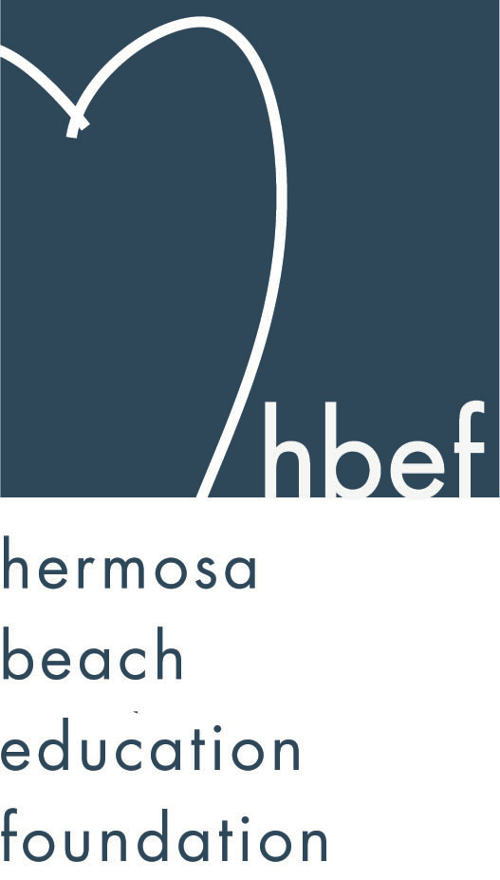Hermosa Beach Education Foundation
Board Meeting Minutes
Tuesday, January 15, 2013

Attendees:
Amy Nachman Barbara Gunning Brian Ledermann Cathy Barrow
Dan Inskeep Dawn Crawford Donna Gin Doug Gneiser
Gloria Vialpando Heather Meugniot Jenn Auville Jennifer Forier
Karen Buchhagen Kim Bailey Kimberly Konis Kimberly Taylor
Laurie Baker Maggie Curtis Michelle Weissenberg Monique Vranesh Nicole Perez Patrick Goshtigian Shelby Gonosey Stephanie Bell
Sue Antrobius Suzy Stouder Sylvia Gluck

Board Members Not Present:
Courtney Unser Dina Stern Jenny Durand Lili McLean
Michelle Lohuis Naomi Immel Sam Rudow

Call to Order
Meeting called to order by Stephanie Bell at 7:31pm

Flag Salute

Approval of Minutes
Doug Gneiser made a motion to approve the November 13, 2012 minutes. Heather Meugniot seconded the motion. Motion carried by voice vote.

Executive Board Reports
Stephanie Bell, President
The HBEF website is being completely restructured and updated and is almost ready to be launched. The HBEF and HVPTO have decided not to march in the Hermosa Beach City St. Patrick’s Day Parade this year. Final numbers from the Skechers Pier to Pier have not arrived yet. Numbers are expected by the end of the month.

Brian Ledermann/Amy Nachman, CO-VP Operations - Policy and Procedures
Brian and Amy had nothing to report.

Jenn Auville, CO-VP Operations – Communication
Mom’s Night Out at The Comedy and Magic Club is sold out and has a waiting list. Due to some inappropriate behavior at the event last year the HBEF board members have been asked to help monitor the behavior of the guests at this year’s event. An email will also be going out to all guests with tickets to remind them of appropriate behavior for The Comedy and Magic Club.
Jenn will be asking for a commitment to return to the HBEF board at the March 12, 2013 meeting. Nominations for new members will also be accepted.
All documents from current and past board members are being collected to place in the HBEF storage unit.

Jennifer Forier, Secretary
Jennifer had nothing to report.

Michelle Weissenberg, VP CFO Treasurer
Michelle reviewed the reimbursement request form and a vendor request form as well as the procedure for requesting a reimbursement or making a vendor request.
Michelle presented a draft financial statement of July 1, 2012 through December 31, 2012.

Patrick Goshtigian, VP CIO Investments
Patrick reviewed the Portfolio Asset Allocations as of December 31, 2012. Yearend value was $1,051,481, which is a 10.2% return. Benchmark was 11.3%. Overall, the portfolio was up $97,147 for the year. The total does include a $2,000 security that needs to be redirected to the Annual Appeal. The HBEF can accept securities from donors.

Maggie Curtis and Shelby Gonosey, CO-VP Annual Appeal
Thursday, November 17, 2012 is Pledge Day. Volunteers are needed. There will be an advertisement in The Beach Reporter. Constant contact messages will be going out. Two Guns have donated coffee to the event. Hang 10 cards are at the printers but will hopefully arrive in time to be available for donors on Pledge Day.
To date, Annual Appeal has raised about $140,000. This is about $30,000 over last year at this time.
Maggie and Shelby are looking into a 100th Day of School campaign to promote the Annual Appeal.

Kimberly Konis, CO-VP Fundraising
Kimberly reported that Heart of Hermosa planning is underway. HOH ticket prices this year will be $150 for one person, $275 for two. Volunteers and auction items are needed for HOH. The Greater Giving software is being explored and the HOH committee feels it will have many great applications for HOH. All bidding at HOH will be done via smartphone and there will be training on the app at the next board meeting.

Dawn Crawford, VP Sponsorships
Hang 10 has 26 partners and has raised $15,000. More Hang 10 partners are welcome. Dawn has contacted all past HBEF sponsors and over half have renewed, raising $47,250. All sponsorship forms are available on the HBEF website and new sponsors are always welcome.

Laurie Baker, VP PR/Communications
Facebook has 296 friends.

Activities Completed
Wine Walk – raised about $20,000.
Fall Mixer – Thank you to the Goshtigian family for hosting the event.
HBFA Poker and Casino Night - $1000 donated to the Annual Appeal
McTeacher’s Night - $2,000 donated to the HBEF
Skecher’s Friendship Circle Pier to Pier Walk – no numbers yet
Gum Tree Santa – raised about $4,000

Other Reports
PTO, Greg Roth
Greg was not present.
Father Daughter Dance has been moved to April 12, 2013. Tickets are on sale for the Father’s Day out event January 20, 2013.

Superintendent, Pat Escalante
Pat was not in attendance.

School Board Representative, Patti Ackerman
Patti was not in attendance.
There will be a special school board meeting on January 23, 2013.
The next regularly scheduled school board meeting is February 13, 2013.

View and Valley Principals, Sylvia Gluck (View) and Kim Taylor (Valley)
Sylvia reported that there is a flag ceremony on February 15, 2013 at View. The 100th Day of School is on February 25, 2013. February 25 - March 1, 2013 is Read Across America. Christine will be organizing guest readers on March 1, 2013. Flu season has struck and flu information has been emailed out to parents.

Kim reminded guests of the check in procedures when visiting a campus. Seventh graders attended camp in Catalina January 7-12, 2013. Eighth graders will be attending astronomy camp January 30 - February 1, 2013. Sixth graders will be going to Malibu March 11-15, 2013. Eighth grade graduation will be June 25, 2013. The new facilities committee will be meeting Wednesday, January 16, 2013 at 6:30pm in the Valley conference room. iPads have arrived and been delivered. Teachers are very excited to put them to use. There will be a flag ceremony on January 18, 2013.

Valley Teacher Representatives, Cathy Barrow (6-8) and Mary Delk (3-5)
Cathy reported that eighth graders are getting presentations from Mira Coast High School and Redondo Union High School and high school registration will be open soon. Eight graders are getting ready to write their books for the third graders.

Mary was not in attendance.

View Teacher Representative, Gia Busse (K-2)
Gia was not in attendance.

Roundtable/Questions/Guests

Calendar
Upcoming 2012-13 HBEF Events
January 30, 2013 – Mom’s Night Out at The Comedy and Magic Club
March 23, 2013 – Hearts of Hermosa
Dates to be determined for:
HB 5000

Upcoming 2012-13 HBEF Meetings
March 12, 2013 – 7:30pm in Tech Lab
April 30, 2013 – 7:30pm in Tech Lab
June 11, 2013 – 7:30pm in Tech Lab
July 9, 2013 – 7:30pm in Tech Lab

Adjournment
Stephanie Bell adjourned the meeting at 8:16pm.

Respectfully submitted by Jennifer Forier

