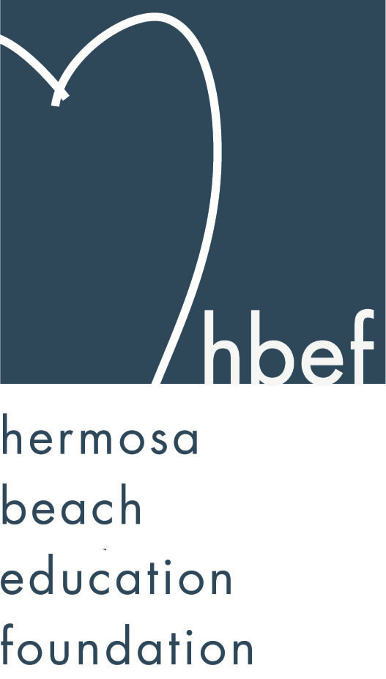Hermosa Beach Education Foundation
Board Meeting Minutes
Tuesday, November 13, 2012

Attendees:
Amy Nachman Brian Ledermann Cathy Barrow Courtney Unser
Dan Inskeep Dawn Crawford Donna Gin Doug Gneiser
Gia Busse Gloria Vialpando Greg Roth Jenn Auville
Jennifer Forier Jenny Durand Karen Buchhagen Kim Bailey
Kimberly Konis Kimberly Taylor Laurie Baker Maggie Curtis
Mary Delk Michelle Lohuis Michelle Weissenberg Monique Vranesh Nicole Perez Pat Escalante Patti Ackerman Sam Rudow Stephanie Bell Suzy Stouder Sylvia Gluck

Board Members Not Present:
Barbara Gunning Dina Stern Heather Meugniot Lili McLean
Naomi Immel Patrick Goshtigian Shelby Gonosey Sue Antrobius

Call to Order
Meeting called to order by Stephanie Bell at 7:38pm

Flag Salute

Approval of Minutes
Maggie Curtis made a motion to approve the September 18, 2012 minutes. Jenn Auville seconded the motion. Motion carried by voice vote.

Executive Board Reports
Stephanie Bell, President
The summer Karaoke Nights at Pointe 705, organized by Kelly Mulvihilll, contributed $817 to the HBEF. Thank you Kelly for your hard work.
The Hermosa Valley teachers and staff donated $2,000 from the McTeacher Night on October 18, 2012 to the HBEF. The HBEF is very thankful to the teachers for their support of the HBEF.
Skecher’s Pier to Pier Walk was held on Sunday, October 28, 2012. Final participant numbers for HBEF are not in yet. Numbers are expected by January 2013.
Boardwalk brought by some funnel fries for the HBEF meeting and expressed their willingness to support the HBEF. Thank you Boardwalk for your support.
Gum Tree Santa photos will be December 6, 2012 from 5:00-9:00pm and December 9, 2012 from 11:00am-5:00pm. Last year this event raised $4,000 for the HBEF. Volunteers are needed. If available please contact Sue Antrobius.
The first planning meeting for Hearts of Hermosa was held on Friday, November 9, 2012.

Brian Ledermann/Amy Nachman, CO-VP Operations - Policy and Procedures
Brian is collecting all documents, paperwork and other goods from board members to make sure that it is all in storage and able to be accessed as needed. If any board members, past or present, have items in their homes please get them to Brian.

Jenn Auville, CO-VP Operations – Communication
Jenn is working on getting the needed volunteers for Hearts of Hermosa. Jenn passed around a volunteer sign up sheet.

Jennifer Forier, Secretary
Jennifer reported that the 2012-13 roster that was emailed out in the meeting reminder should be the final version.

Michelle Weissenberg, VP CFO Treasurer
Michelle reviewed the reimbursement request form and a vendor request form as well as the procedure for requesting a reimbursement or making a vendor request.
Financials are done on a quarterly basis and will be reviewed at the January HBEF meeting.

Patrick Goshtigian, VP CIO Investments
Patrick was not present. Brian reviewed the Portfolio Asset Allocations as of October 31, 2012. Current value is $1,032, 559, which is an 8.4% return. Benchmark was 10.3%. Overall, the portfolio is up $80,219 year to date.

Maggie Curtis and Shelby Gonosey, CO-VP Annual Appeal
Maggie is preparing a constant contact message to serve as a soft launch for the Annual Appeal. To date Annual Appeal has raised $60,000. A new Annual Appeal brochure is being printed and will be mailed out later in the school year. Maggie and Shelby have had several discussions with the HBCSD administrators to ensure that fundraising goals for the HBEF are still in line with what the district feels is most critical for the students. The proposed fundraising goals for 2013-14 school year are $325,000 for class size preservation (previously called class size reduction), $275,000 for middle school electives, $100,000 for science lab (3-5), $100,000 for library, $100,000 for PE (1-5) and $100,000 for 21st century curriculum and technology (a new category). This is a total of $1,000,000. The goal for HBEF this year is 100% participation in the Annual Appeal. 100% of the students benefit so 100% of the families should participate at some level. Maggie and Shelby are working on creating a grandparents club for grandparents that donate to the annual appeal. Maggie and Shelby are working on creating a new updated HBEF website.

Kimberly Konis, CO-VP Fundraising
Kimberly reported that HOH planning is underway. HOH ticket prices this year will be $150 for one person, $275 for two.

Dawn Crawford, VP Sponsorships
HBEF’s First Annual Wine Walk was held on Saturday, September 29, 2012 from 5:30-9:30pm. Thirteen local eateries and 5 wineries donated their goods to the event. The event raised about $20,000 for the HBEF.
Dawn presented the new sponsorship levels for the 2012-13 fundraising year. Sponsorship levels will be available at HBEF.org. To date, $32,000 in sponsorship monies has been collected for the year. Dawn is working on contacting all past sponsors to get onboard for the new year. She will then focus on getting new sponsors. Hang 10 partnership levels for 2013 were also reviewed.

Laurie Baker, VP PR/Communications
Facebook has 277 friends. HBEF Mom’s Night Out tickets are selling fast.

Activities Completed
Wine Walk – raised about $20,000.
Fall Mixer – Thank you to the Goshtigian family for hosting the event.
HBFA Poker and Casino Night - $1000 to be donated to the Annual Appeal
McTeacher’s Night - $2,000 donated to the HBEF
Skecher’s Friendship Circle Pier to Pier Walk – no numbers yet

Other Reports
PTO, Greg Roth
PTO is working on getting together the final numbers for the Halloween carnival. Fresh and Easy is donating $1 for every $20 in receipts collected. Drop off boxes are available in the Valley and View offices.

Superintendent, Pat Escalante
With the passing of Proposition 30, all furlough days were rescinded. The last day of school will June 26, 2012. Students will receive 180 instructional days. HBCSD has an API of 944, the highest in the South Bay.

School Board Representative, Patti Ackerman
Patti thanked the Valley teachers and staff for organizing and participating in McTeacher Night. Patti reminded the HBEF that we need to make sure that the school community understands that the passage of Proposition 30 is not a solution to the budget deficit, it just stops the bleeding. Fundraising will still be critical for our schools. The next school board meeting will be held Wednesday, November 14, 2012 at 7pm.

View and Valley Principals, Sylvia Gluck (View) and Kim Taylor (Valley)
Kim reported she attended the Skecher’s Pier to Pier Walk and had a great time. Valley middle school students are preparing for their outdoor education trips. Safe School Ambassador anti-bully training starts in December. 8th graders visited Mira Costa. Redondo Union High school will be coming to HVS to make a presentation. Eighth graders are discussing what they want their legacy to be. Teacher training this year is focusing on special education and technology. Valley book fair is being held November 13-16, 2012.

Sylvia reported that View has many classes working on holiday performances. Dolphin time started on November 1, 2012. Numerous volunteers are on campus daily and the staff appreciates all the support.

Valley Teacher Representatives, Cathy Barrow (6-8) and Mary Delk (3-5)
Cathy reported that Valley held a mock presidential election. Middle school just ended their first quarter. The dress code is being reviewed and enforced on campus.

Mary reported that teachers are working well as grade level teams and morale is great at Valley thanks to all the support the teachers are feeling.

View Teacher Representative, Gia Busse (K-2)
Gia reported that Friendship Circle is going well at View. Volunteers are always welcome to assist at the Friendship Circle. Kindergarteners have adjusted to their schedule and are doing well working on literacy skills and the Daily 5 in the afternoons.

Board Action
Michelle Weissenberg and Michelle Lohuis reviewed the 2012 Teacher Grants
The following teacher grants were submitted:
**Karen Guerrero requested $2,731 for headphones on the library. Since the request, funds were made available from another source.
**Karen Guerrero requested $611 for Accelerated Reading books for the View library. The executive board recommends this grant be approved.
**Second grade teachers requested $1,125 for buses to attend the Young Publishers workshop in Venice. Traditionally, HVPTO has funded buses for field trips and because this does not constitute a program. The executive board is not recommending this grant.
**Robyn Alatorre requested $500-820 for Art Exhibition Panels. This does not constitute a program so the executive board is not recommending this grant.
**Cathy Barrow requested $1,250 for the 8th grade/3rd grade book writing program. The executive board recommends this grant be approved.
**Kinder, 1st, 2nd and 5th grade teachers have requested iPads to work in sync with the Elmos to enchance the writer’s workshop program. The executive board recommends approving this grant.
The following action is recommended:
Approve $611.81 in AR books, $1,250 for Barrow’s book writing, and $13,500 for teacher iPads.

Vote to Approve the 2012 HBEF Teacher Grants as recommended
Suzy Stouder made a motion to approve the HBEF Teacher Grants as presented by Michelle Weissenberg and Michelle Lohuis. Kimberly Konis seconded the motion. Motion carried by voice vote.

The following email came after the meeting from Stephanie Bell regarding Grants:
In our hurry at the end of the night, we failed to discuss the poetry grant money of $6,250 that was set aside last year for the current year's poetry program. As we discussed at previous meetings, while we still want to support programs such as these, it is no longer the best way to spend our limited funds. Going forward, the $6,250 will be rolled back into the general fund so that it can support all students. The year we are able to do something that will support the poetry program for several years to come. The money will be used by the school to provide 3rd and 4th grade teachers with iPads. There are several applications that are specifically targeted toward poetry that the teachers will be using to continue to give our students a poetry program. Of course, while we know the iPads were granted through the poetry program, they will have a broad use in the classroom. This combined with the teacher grants funds of $15,000, will allow the HBEF to supply every teacher from K-5 with an iPad for use in their classroom! We are very excited to help our school become more tech savvy and have each classroom have the same tools to use to better educate our children.

Roundtable/Questions/Guests
Doug Gneiser reminded the board of the $1,000,000 budget deficit that HBCSD is faced with annually to support the current programs our students benefit form. It is critical for the community to understand that the passage of Proposition 30 will not reduce this deficit. We still need to strive for 100% participation in the HBEF’s fundraising efforts.

Calendar
Upcoming 2012-13 HBEF Events
December 6, 2012 – Gum Tree Santa 5:00-9:00pm
December 9, 2012 – Gum Tree Santa 11:00am-5:00 pm
January 30, 2013 – Mom’s Night Out at the The Comedy and Magic Club
March 23, 2013 – Hearts of Hermosa
Dates to be determined for:
HB 5000

Upcoming 2012-13 HBEF Meetings
January 15, 2013 – 7:30pm in Tech Lab
March 12, 2013 – 7:30pm in Tech Lab
April 30, 2013 – 7:30pm in Tech Lab
June 11, 2013 – 7:30pm in Tech Lab
July 9, 2013 – 7:30pm in Tech Lab

Adjournment
Stephanie Bell adjourned the meeting at 9:16pm.

Respectfully submitted by Jennifer Forier

