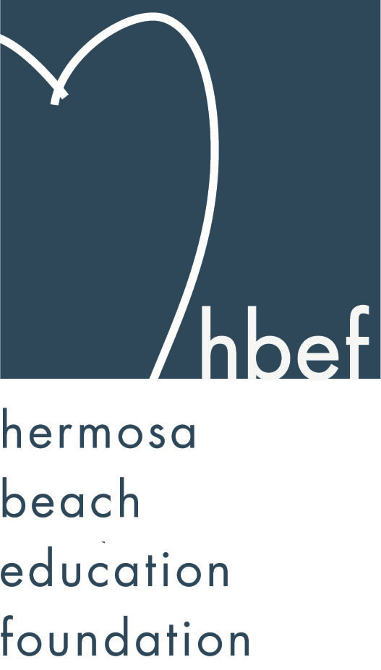Hermosa Beach Education Foundation
Board Meeting Minutes
Tuesday, September 16, 2014

Board of Directors Attendees:
Ali Malone Allison Ludlow Brian Ledermann Brian Parker
Carla Persell Carol Herschelman Cindy Butler Cristina Kabealo
Dan Inskeep Debra Luckey Donna Gin Heather Meugniot Heather Olson Jennifer Forier Jenny Fix Jessica Walls
Laurie Baker Lisa Searer Lynn Barr Maggie Curtis Michelle Weissenberg Monique Vranesh Nicole Perez Patrick Goshtigian
Suzy Stouder Tiffany Miller Tiffani Soporito

Board Directors Not Present:
Courtney Unser Doug Gneiser Gail Laskowski Karen Buchhagen
Kimberly Konis Zipporah Kiger

Honorary Board of Directors:
Cathy Barrow David Hart Kimberly Taylor Lisa Claypoole Louisa Cushman Marlene Ramirez Pat Escalante Sylvia Gluck

Guests:
Carrie King Ellie Fernandez Gillian Smith Jen Williams
Kammella Tadason Patti Ackerman Paulette O’Hara Regina Mitchell
Call to Order
Meeting called to order, in the Valley Multipurpose Room, by Ali Malone at 7:40pm. HVPTO meeting was held as well. See HVPTO meeting minutes for detailed HVPTO information.

Flag Salute

Presentation of Donations
Erin and Reid Inskeep presented a check for $965 from their summer recycling efforts. The money is to be placed in the HBEF endowment fund.

Approval of Minutes
Jennifer presented the minutes from the June 10, 2014 Board meeting. Corrections were needed, Wine Walk date changed to October 18, 2014, Fall Mixer date changed to September 24, 2014. Lynn Barr moved to approve the minutes and Lisa Searer seconded the motion. Motion approved, pending corrections. Minutes will now have a footer reflecting rather minutes are pending approval or approved.

Executive Board Reports

Ali Malone, President
Ali met with various board members over the summer and she is working to make sure she is informed on all aspects of the organization and events.

Brian Ledermann, Operations - Policy and Procedures
Brian asked that all event paperwork be submitted for placement in storage. Any relevant documents should also be placed in the Dropbox for access from the board as needed. Brian thanked the volunteers that worked a shift in the Fiesta Hermosa Beer Garden. A portion of the proceeds will be donated to the HBEF.

Jennifer Forier, Secretary
There are still a few commitment and expectation forms to be collected. A Teacher Grant timeline has been determined. Applications will go to teachers September 22, 2014, applications are due October 10, 2014, applications will be reviewed the week of October 13-17, 2014, requests will be presented to exec board on October 28, 2014 and board vote will occur at the November 4, 2014 meeting. The 2014-15 HBEF roster is complete and will be emailed to the board and placed in Dropbox immediately following the board meeting. A Fall Mixer food and drink donation sign up was circulated. Julie Nunis is working on a Sunscreen Film Festival for the weekend of October 10-12, 2014. Tickets revenues will be donated to the HBEF.

Dan Inskeep, Treasurer
Dan reviewed the Profit and Loss Statement and Balance Sheet for July 1 through September 16, 2014. Dan is looking in to ways to reduce the annual amount HBEF spends on credit card fees and interest.

Patrick Goshtigian, CIO Investments
Patrick presented the Portfolio Asset Allocation as of August 31, 2014 for review. The portfolio showed a 6.3% total return. This is slightly lower than the benchmark (7.9%). Ending market value is $1,566,275. Overall, the endowment is up $92,968 for 2014.

Gail Laskowski and Lisa Searer, Annual Appeal
Information on recurring donations has been sent out. A mailing went out to all kinder parents to introduce them to the Annual Appeal. Annual Appeal brochures are being printed.

Lynn Barr, Fundraising
Lynn thanked Cristina Kabealo and Tiffani Miller for chairing the back to school picnic on September 13, 2014. The event was well attended and a success. The fall mixer will be held on September 24, 2014 at the home of Suzy Stouder. Kimberly Konis and Suzy Stouder are chairing the event. This year the HVPTO will also be participating in the mixer. Wine Walk will be held October 18, 2014. Wine Walk chairs are hard at work planning. Skechers Walk will be held October 26, 2014. Monique Vranesh and Donna Gin are chairing the event. The HBEF will be paying for all teachers to walk and forming teams for each teacher.

Heather Olson, Sponsorships
Heather reported that new sponsorship forms are in the works and will be up on Dropbox for board access. We are a working board and we can all keep our ears open for sponsorship opportunities. Northwest Realty Brokers has signed up to be a Wine Walk donor.

Laurie Baker, Public Relations
Laurie completed and emailed out the annual HBEF newsletter over the summer. The eCity newsletter contained information about the back to school picnic. Laurie will continue to work with them to promote other HBEF events. HBEF now has an Instagram account and is gaining followers. HBEF has 535 Facebook friends.

Activities Completed for 2014-2014
September 12, 2014 – Back To School Picnic

Board Action

Other Reports

PTO, Jenny Fix/Louisa Cushman
For detailed information review HVPTO meeting minutes.
HVPTO raised $9,000 at their Labor Day Parking Lot fundraiser. The HVPTO website is being revamped and will be up and running shortly. The new website will feature a spirit wear store for online purchases. The new spirit wear is very popular and grossed $20,000 in sales. There will be a wrapping paper drive September 19th-October 3rd with a new vendor this year. The HVPTO purchased umbrellas for the View lunch benches. The eScript contest is going on. Blue Zone Project forms can be signed and submitted. Each form submitted will earn a dollar for the HVPTO. Operation gratitude candy collection and letter writing will happen in October. The Halloween Carnival will be held October 24, 2014 at 5pm. Halloween raffle ticket sales are coming in October. Scrip is for sale. Family portraits are October 11th and 12th.

Superintendent, Pat Escalante
HBCSD enrollment is at 1,484 students. Several middle school teachers are working 120% to accommodate the large number of middle school students. Any increased student enrollment will cause issues with the 24-1 class sizes for K-3. Exceeding the enrollment would result in lost revenue. The district office is temporarily located in the Valley maintenance building and will be moving to South Park in October. The school board voted 5-0 to not renew the charter school contract with Opportunities for Youth and Opportunities for Education.

School Board Representative, Lisa Claypoole
Lisa thanked Pat for her work and reported that Pat’s contract had been extended at the last school board meeting. Lisa spoke of the importance of getting informed on Measure Q and being ready to vote in November.

View and Valley Principals, Sylvia Gluck (View) and Kim Taylor (Valley)
Sylvia reported TK and 2nd grade now have recess before sitting down to lunch and students appear to be eating more of their lunches. Sylvia is sending out a monthly View newsletter. Teachers are receiving math trainings and common core trainings. View received a grant to implement music programs for K-2 students.

Kim reported that the front office has moved to where the district office was previously located. Back to School Night was well attended. There is an onsite common core coach for the K-8th grade teachers. There will be a hip-hop and theater residency happening. Service points have been reevaluated this year. Half an hour of service earns one point. HBEF and HVPTO can offer up to maximum of 3 points for service at on campus HBEF/HVPTO events. Event chairs using student volunteers for activities should submit a list of names and hours to Jennifer Forier (HBEF) or Maggie Curtis (HVPTO). Names will be submitted to Kim. Kim will only sign off on hours submitted by Jennifer and Maggie. Students are responsible for going in to Kim to be signed off. Only Kim can sign off on HBEF/HVPTO hours.

View Teacher Representative, Marlene Ramirez (K-2)
The HVPTO back to school staff lunch was wonderful and the View teachers are thankful for their Office Depot cards. View teachers are implementing the Mind Up program and Writer’s Workshop. View Back to School night was well attended. The picnic was a nice event and a great place for parents to learn about all the activities that are happening on campus.

Valley Teacher Representatives, Cathy Barrow (6-8) and David Hart (3-5)
David reported that the Valley teachers appreciated the HVPTO back to school staff lunch and their Office Depot cards. The Valley Back to School Night was well attended and the state of the district talk was full. The teachers’ union has voted to support Measure Q. Field trips are being booked, common core is being implemented, Writer’s Workshop is going strong, and Reader’s Workshop is being looked at.

Cathy reported that the middle school teachers enjoyed the back to school lunch and the Office Depot gift cards. Cathy thanked the HBEF for her teacher grant for the 3rd/8th grade books. There are flag ceremonies planned for the year. The Hermosa Beach Police will be presenting a digital citizenship assembly.

Roundtable/Questions/Guests
Ryan Nowicki, chairperson for Yes on Q For Quality Hermosa Schools, spoke about Measure Q. Ryan presented a FAQ sheet for review and provided contact information for anyone wishing to be involved with the campaign.

Calendar
Upcoming 2014-15 HBEF Events
September 24, 2014 - HBEF Fall Mixer
October 18, 2014 – Wine Walk
October 26, 2014 – Skecher’s Pier To Pier Walk
November 22, 2014 - Santa Photos at gum tree 10-4pm
November 29, 2014 - Santa Photos at gum tree 10-4pm
January 28, 2015 - Mom’s Nights Out at The Comedy and Magic Club
March 21, 2015 – Hearts of Hermosa
Annual Appeal - ongoing

Upcoming 2014-15 HBEF Meetings
November 4, 2014 – 7:30pm in Valley MPR
January 13, 2015 – 7:30pm in Valley MPR
March 10, 2015 – 7:30pm in Valley MPR
May 12, 2015 – 7:30pm in Valley MPR
June 16, 2015 – 7:30pm in Valley MPR

Adjournment
Ali Malone adjourned the meeting at 8:49pm.

Respectfully submitted by Jennifer Forier

